*Assignment*

*Task 1;*

*#include<iostream>*

*using namespace std;*

*int main()*

*{*

*void\* ptr = NULL;*

*int a = 5;*

*double b = 8.5;*

*int\* aptr = &a;*

*double\* bptr = &b;*

*ptr = aptr;*

*cout << ptr<<endl;*

*cout << aptr<<endl;*

*//cout << \*ptr; //Error will show here because we cannot perform operation on '\*' using void datatype*

*//aptr = bptr; //Error will show here we cannot assing values to different datatype*

*cout << \*aptr<<endl;*

*cout << \*bptr<<endl;*

*aptr = (int\*)bptr;*

*cout << aptr<<endl;*

*cout << bptr<<endl;*

*cout << \*aptr<<endl;*

*cout << \*bptr<<endl;*

*system("pause");*

*return 0;*

*}*

*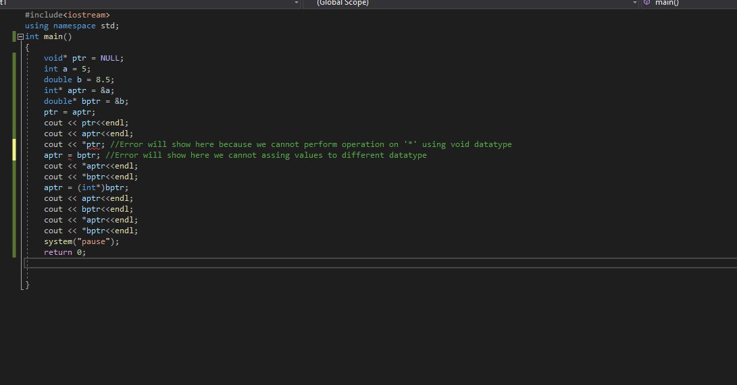*

*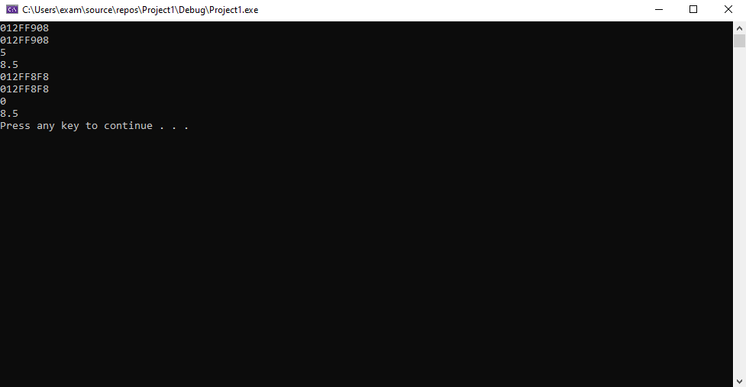*

Task no.2

